**Semester 2 (Units 3 and 4) Examination, 2016**

**Question/Answer Booklet**

**MATHEMATICS APPLICATIONS**

**Section One: Calculator-assumed**

Student Name/Number: ______________________________________________

Teacher Name: ______________________________________________

**Time allowed for this section**

Reading time before commencing work: ten minutes

Working time for this section: one hundred minutes

**Materials required/recommended for this section**

**To be provided by the supervisor:** This Question/Answer Booklet

Formula Sheet (retained from Section One)

**To be provided by the candidate:**

Standard items: pens (blue/black preferred), pencils (including coloured), sharpener,

correction fluid/tape, eraser, ruler, highlighters

Special items: drawing instruments, templates, notes on 2 unfolded sheets of A4 paper, and up to three calculators approved for use in the WACE examinations

**Important note to candidates**

No other items may be taken into the examination room. It is **your** responsibility to ensure that you do not have any unauthorised notes or other items of a non-personal nature in the examination room. If you have any unauthorised material with you, hand it to the supervisor **before** reading any further.

**Structure of this paper**

|  |  |  |  |  |  |
| --- | --- | --- | --- | --- | --- |
| Section | Number of questions available | Number of questions to be answered | Working time (minutes) | Marks available | Percentage of exam |
| Section One: Calculator-free | 6 | 6 | 50 | 51 | 35 |
| Section Two: Calculator-assumed | 10 | 10 | 100 | 109 | 65 |
|  | | | | | 100 |

**Instructions to candidates**

1. The rules for the conduct of School exams are detailed in the *College assessment policy*. Sitting this examination implies that you agree to abide by these rules.
2. Write your answers in this Question/Answer Booklet.

3. You must be careful to confine your responses to the specific questions asked and to follow any instructions that are specific to a particular question.

1. Spare pages are included at the end of this booklet. They can be used for planning your responses and/or as additional space if required to continue an answer.
   * Planning: If you use the spare pages for planning, indicate this clearly at the top of the page.
   * Continuing an answer: If you need to use the space to continue an answer, indicate in the original answer space where the answer is continued, i.e. give the page number. Fill in the number of the question that you are continuing to answer at the top of the page.
2. **Show all working clearly.** Your working should be in sufficient detail to allow your answers to be checked readily and for marks to be awarded for reasoning. Incorrect answers given without supporting reasoning cannot be allocated any marks. For any question or part question worth more than two marks, valid working or justification is required to receive full marks. If you repeat any question, ensure that you cancel the answer you do not wish to have marked.
3. It is recommended that you **do not use pencil**, except in diagrams.
4. The Formula Sheet is **not** to be handed in with your Question/Answer Booklet.

**Section Two: Calculator-assumed 65% (109 Marks)**

This section has **10** questions. Answer **all** questions. Write your answers in the spaces provided. Spare pages are included at the end of this booklet. They can be used for planning your responses and/or as additional space if required to continue an answer.

* + Planning: If you use the spare pages for planning, indicate this clearly at the top of the page.
  + Continuing an answer: If you need to use the space to continue an answer, indicate in the original answer space where the answer is continued, i.e. give the page number. Fill in the number of the question that you are continuing to answer at the top of the page.

Suggested working time: **100 minutes**.

**Questions begin on the next page**

**Question 7 (10 marks)**

Comparison of the population figures of Baldivis in the years 2013 and 2014 identified it as one of the suburbs of Perth with the largest and fastest population growth.

The population at the end of 2013 was 23 500 and it increased by 3 500 in 2014.

(These figures have been rounded to the nearest 500)

(a) Write an expression that shows the percentage increase in the population in 2014 to be 15% (to the nearest percent). (1 mark)

If the population continues to grow at the same rate, the population of Baldivis can be determined using the recursive relation

$P_{n+1 = }$ 1.15 $P_{n}$ where $P_{1}$ is the population in 2013

(b) Using this rule, complete the following table for the population of Baldivis. (2 marks)

|  |  |  |  |  |  |
| --- | --- | --- | --- | --- | --- |
| **Number of years after Dec 31, 2012** | 1 | 2 | 3 | 4 | 5 |
| **Population of Baldivis** | 23 500 |  |  |  |  |

(c) What will be the population of Baldivis in 2020? (2 marks)

Ellenbrook also experienced one of the largest increases in population in the Perth suburbs in 2014. The population increased by 2 400 in that year from a population of 29 500 in 2013.

The percentage increase was 8%.

(d) Deduce a non recursive rule for the *nth* termtodetermine the population of Ellenbrook in any year. Assume that the population continues to grow at the same rate. (2 marks)

(e) Use the rule from part (d) to complete the following table. (2 marks)

|  |  |  |  |  |  |
| --- | --- | --- | --- | --- | --- |
| **Number of years after**  **Dec 31, 2012** | 1 | 2 | 3 | 4 | 5 |
| **Population of Ellenbrook** |  |  |  |  |  |

(f) Identify the year in which the population of Baldivis will be greater than the population of Ellenbrook for the first time. (1 mark)

**Question 8 (10 marks)**

The diagram below shows the flow of water from a river to a lake through a system of canals. The numbers indicate the maximum capacity of each canal in kilolitres per hour.

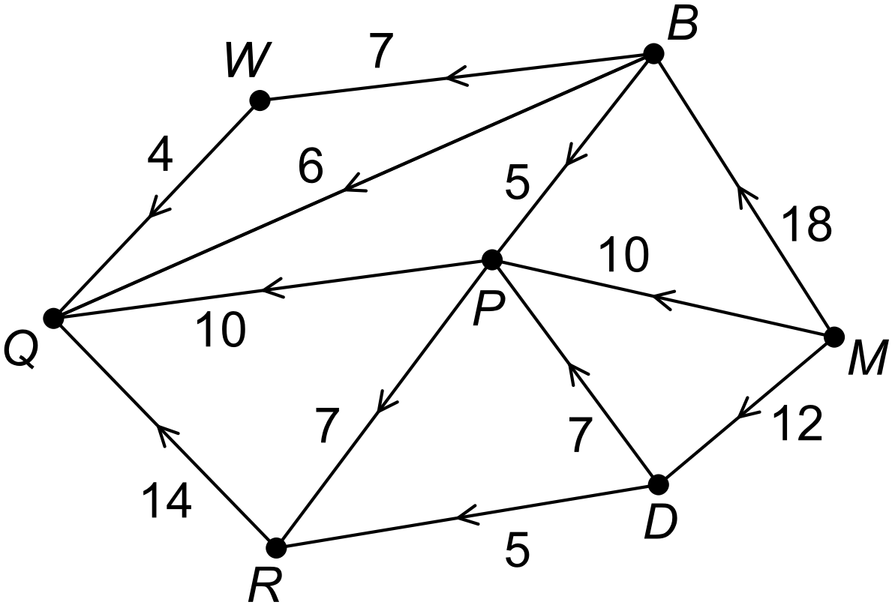

(a) Identify the sink of the system. (1 mark)

(b) What is the maximum input for the system of canals? (1 mark)

(c) Determine the maximum flow from the river to the lake. (4)

List the paths of the canals used and state the maximum capacity for each path.

(4 marks)

(d) Draw the “minimum cut” on the diagram below. (1 mark) (2)



(e) Describe the relationship between the “minimum cut” and the “maximum flow”.

(1 mark)

(f) On investigation, it was found that the capacity of the canal from P to Q could be increased by an extra 6 kilolitres per hour. How does this increase affect the maximum flow of water to the lake? Justify your decision. (2 marks)



**Question 9 (9 marks)**

The information supplied to passengers on flights includes the external temperature and the altitude (height above sea level) at which they are flying. Jules noticed that the higher they flew the colder it was outside. He started to record the data supplied when he was travelling on his holidays. Jules prepared statistical reports of his findings and they included the two graphs below.

**GRAPH A**

**GRAPH B**

(a) Calculate the correlation coefficient for the relationship as shown in Graph A. (1 mark)

(b) Identify the response variable. (1 mark)

(c) What percentage of the variation in temperature in Graph B is accounted for by the change in altitude? (1 mark)

It is evident in both graphs that there is a strong linear relationship between the variables.

(d) Can you conclude that changes in altitude are causing the external temperature to change? Justify your decision. (1 mark)

(e) Which graph shows a stronger linear relationship between the two variables?

Give two reasons to justify your answer. (3 marks)

(f) Which graph should be used as the more reliable indicator of the nature of the relationship between the two variables? Justify your choice of answer. (1 mark)

(g) Jules is planning to collect more data to further his investigation. What could he do to ensure his data is a more reliable indicator of the relationship between these two variables? (1 mark)

**Question 10 (11 marks)**

Data from the Australian Bureau of Statistics has been used to create the graph below. It shows the total number of dwellings approved in Western Australia for each quarter from March 2011 until September 2015.

Some of the data relating to the number of approvals is reproduced in the table below.

|  |  |  |  |  |  |  |  |
| --- | --- | --- | --- | --- | --- | --- | --- |
| **Year** | **Quarter** | **Month** | **Number of approvals** | **Approvals as a % of year's season average** | **Deasonalised data** | **Season** | **Seasonal index** |
| 2011 | 1 | Mar | 3937 | 96% | 4180 | Mar | 94% |
|  | 2 | Jun | 4225 | 103% | 4433 | Jun | 95% |
|  | 3 | Sep | 4303 | 105% | 4063 | Sep |  |
|  | 4 | Dec | 3915 | 96% | 3742 | Dec |  |
| 2012 | 5 | Mar | 4040 | 100% | 4289 |  |  |
|  | 6 | Jun | 3237 | 80% | 3397 |  |  |
|  | 7 | Sep | 4207 | 104% | 3973 |  |  |
|  | 8 | Dec | 4700 | 116% | 4493 |  |  |
| 2013 | 9 | Mar | 4809 | 87% | 5105 |  |  |
|  | 10 | Jun | 5437 | 98% | 5705 |  |  |
|  | 11 | Sep | 6034 | 109% | 5698 |  |  |
|  | 12 | Dec | 5937 | 107% | 5675 |  |  |
| 2014 | 13 | Mar | 5727 | 94% | 6080 |  |  |
|  | 14 | Jun | 6088 | 100% | 6388 |  |  |
|  | 15 | Sep | 6437 | 106% | 6079 |  |  |
|  | 16 | Dec | 6066 | 100% | 5799 |  |  |
| 2015 | 17 | Mar | 5153 |  |  |  |  |
|  | 18 | Jun | 5596 |  |  |  |  |
|  | 19 | Sep | 5324 |  |  |  |  |

(a) Describe the evidence indicating that the changes to the data are seasonal. (1 mark)

(b) Calculate the deseasonalised value for March 2015. (1 mark)

(c) Determine the seasonal index for the September quarter. (2 marks)

The least squares line for modelling the data trend was determined as follows:

DEASONALISED data = 175 x quarter + 3453

(d) Describe the periodic changes in the number of dwellings approved? (2 marks)

(e) Use the equation for the line to predict the total number of dwellings that were approved in June 2015. (2 marks)

(f) Describe the accuracy of your prediction in part (c) and justify your conclusion.

(2 marks)

(g) To justify using this equation in coming years the trend will need to continue. What evidence indicates this may not happen? (1 mark)

**Question 11 (13 marks)**

Three projects are planned for the network of cycle routes linked by stations where bikes can be borrowed or returned. Where the network is shown, the nodes represent the stations and the cycling distances between stations (km) are shown on the edges of the graph. A bike can be borrowed at one location and returned to another.

(a) Project A

A race is planned so that each station is visited just once except that the race will start and end at Station P. Determine the distance covered in the race and use the diagram below to show the routes that will be used. (2 marks)

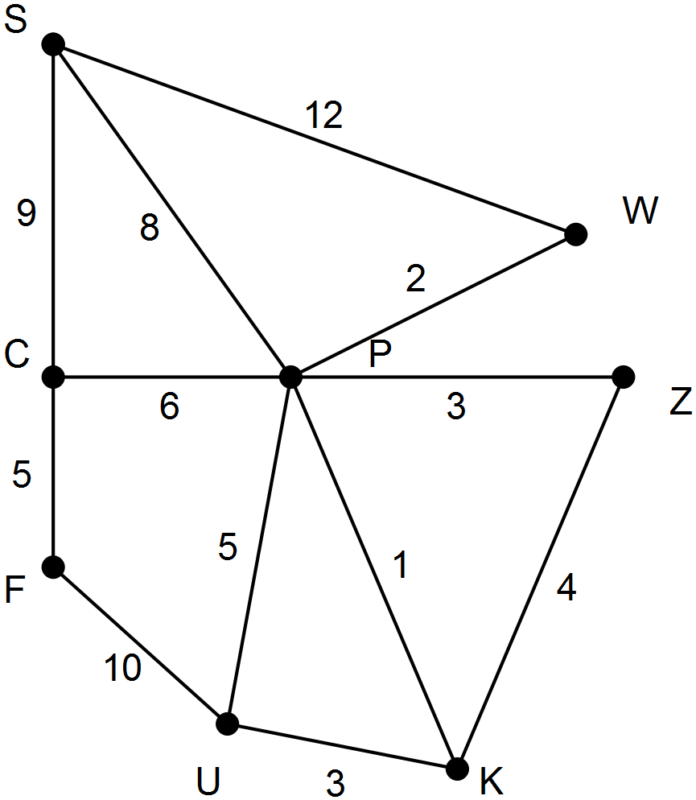

(b) Project B

The network is to be upgraded but initially the upgrade will only be done so that all stations are linked and the cost is as low as possible. At a cost of $5000 per km what is the least amount this initial upgrade will cost? Show the routes to be upgraded on the graph below.

(3 marks)



(c) Project C

The manager is investigating the cost of creating a Tourist Way in which all routes are travelled just once and the bikes can be returned to a different station to the one from which they were borrowed.

(i) The manager believes it is impossible to cycle between all stations without repeating a route between them. How you know he is correct? (1 mark)

(ii) He can create more routes between any two stations of the same distance as their existing routes. Where can he add an extra route or routes to create the Tourist Way

and keep the cost of the extension to a minimum? (2 marks)

(iii) Amend the diagram below to show the Tourist Way that is created with the extra route(s) from part (ii). Create a list showing the stations in the order that they will be visited.

(2 marks)

(d) Select one or more of the terms given to describe the resulting network for each of the Projects A to C. (3 marks)

Terms: Eulerian, Hamiltonian, Hungarian, Prim’s, circuit, trail, minimum spanning tree

|  |  |
| --- | --- |
| **Project** | **Terms** |
| **A** |  |
| **B** |  |
| **C** |  |

**Question 12 (13 marks)**

The table below shows the number of people volunteering to foster dogs each month at the local animal shelter. A few times over the period of the two years advertising campaigns to attract more volunteers were conducted and were successful.

|  |  |  |  |  |  |  |  |  |  |  |  |  |
| --- | --- | --- | --- | --- | --- | --- | --- | --- | --- | --- | --- | --- |
| **Month** | **1** | **2** | **3** | **4** | **5** | **6** | **7** | **8** | **9** | **10** | **11** | **12** |
| **Number** | 12 | 11 | 20 | 18 | 12 | 11 | 10 | 12 | 22 | 19 | 13 | 12 |
| **Month** | **13** | **14** | **15** | **16** | **17** | **18** | **19** | **20** | **21** | **22** | **23** | **24** |
| **Number** | 13 | 13 | 12 | 11 | 24 | 21 | 12 | 14 | 13 | 12 | 12 | 26 |

(a) Construct a time series plot to show the change in the number of people volunteering over the two years.



(2 marks)

(6 marks)

(b) Describe the long term trend of these time series data. (1 mark)

(c) Provide evidence for your conclusion about the nature of the long-term trend as described in part (b). (1 mark)

(d) Which of the following terms can be used to describe these data? Clearly identify those you have selected and those not applicable.

TERMS: seasonal, cyclic, systematic, calendar-related, include outliers (2 marks)

(e) Describe in detail (without using the terms provided in part (d)) the pattern of the fluctuations in these data. (3 marks)

**Question 13 (11 marks)**

In order to purchase some shares, Marilyn borrows $60 000 from a financial institution that charges interest on loans at a rate of 1.1% per month.

(a) Determine the amount of interest charged for the first month. Show the calculation used. (2 marks)

Each month, Marilyn makes a repayment of $2000, which is deducted from the amount she owes after the interest for the month has been added.

(b) How much does Marilyn owe at the end of the first month after she has made one repayment? Show the calculation used. (2 marks)

A condition of the loan is that both the amount she repays monthly and the interest rate charged will remain the same for the duration of the loan.

The amount that Marilyn owes at the end of each month of the loan can be expressed by the following recursive relation

${ A}_{n+1}$ = 1.011 $A_{n}$–  *k $A_{0}$* = 60 000

(c) Rewrite this recursive relation replacing *k* by the appropriate value. (1 mark)

(d) How much does Marilyn owe at the end of

(i) the second month? (1 mark)

(ii) the second year? (1 mark)

(e) How long will it take Marilyn to pay off the loan? (1 mark)

(f) Determine the total amount of Marilyn’s repayments. (2 marks)

(g) Determine the amount of interest Marilyn will have to pay on the loan. (1 mark)

**Question 14 (10 marks)**

A city park has some notable features. The adjacency matrix below shows the number of paths between these features, which are a rose garden (R), an aviary (A), a kiosk (K), a canoe hire facility by a lake (C) and the main gate itself (G).

*C A R G K*

$\begin{matrix}C \\ A \\ R \\ G \\ K\end{matrix}$ $\left[\begin{matrix}1 & 1 & 0 & 0 & 1 \\ 1 & 0 & 0 & 1 & 0 \\ 0 & 0 & 0 & 1 & 2 \\ 0 & 1 & 1 & 0 & 1 \\ 1 & 0 & 2 & 1 & 0\end{matrix}\right]$

Use this matrix to answer the following questions.

(a) What does the sum of the numbers in the fourth column represent? (1 mark)

(b) What is the number in the third row of the fifth column and what does it represent?

. (2 marks)

(c) Describe what the different numbers on the leading diagonal represent. (2 marks)

(d) The matrix is symmetrical about the leading diagonal. Explain the significance of the symmetry. (1 mark)

(e) Is it possible to walk directly from the gate to the canoe hire facility? Justify your decision. (1 mark)

(f) Complete the graph below showing the paths in the park represented by the adjacency matrix.

(3 marks)

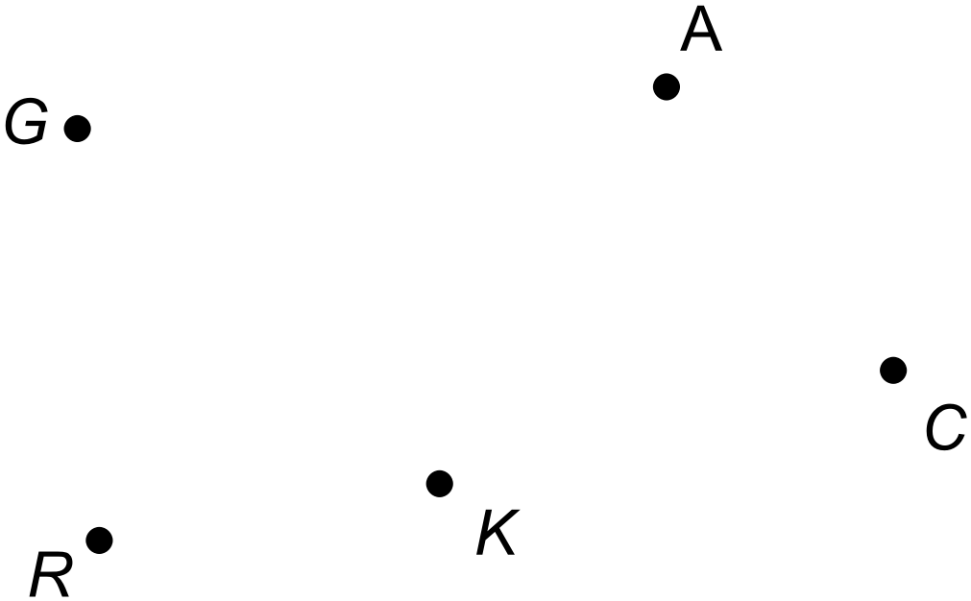

**Question 15 (14 marks)**

The heights and weights of ten footballers are given in the table below.

|  |  |  |  |  |  |  |  |  |  |  |
| --- | --- | --- | --- | --- | --- | --- | --- | --- | --- | --- |
| **Player** | **1** | **2** | **3** | **4** | **5** | **6** | **7** | **8** | **9** | **10** |
| **Height**  **(cm)** | 174 | 178 | 180 | 182 | 183 | 185 | 190 | 193 | 194 | 203 |
| **Weight**  **(kg)** | 72 | 79 | 82 | 84 | 88 | 83 | 92 | 97 | 85 | 104 |

(a) Determine the equation for the least squares line that models how height is affected by weight for these ten players. (2 marks)

(b) Determine the coefficient of determination for this linear association. (1 mark)

(c) Predict the weight for a player who is 211 cm tall. (1 mark)

(d) Comment on the reliability of your prediction and justify your conclusion. (2 marks)

For another ten players from the same team a different linear equation was determined and then used to predict the weight for each player.

|  |  |  |  |  |  |  |  |  |  |  |
| --- | --- | --- | --- | --- | --- | --- | --- | --- | --- | --- |
| **Player** | **1** | **2** | **3** | **4** | **5** | **6** | **7** | **8** | **9** | **10** |
| **Height**  **(cm)** | 175 | 179 | 182 | 182 | 183 | 186 | 193 | 195 | 198 | 200 |
| **Weight**  **(kg)** | 82 | 81 | 71 | 81 | 84 | 86 | 104 | 101 | 101 | 102 |
| **Predicted weight (kg)** | 75 | 79 | 83 | 83 | 84 | 88 | 96 | 98 | 102 | 104 |
| **Residuals** |  |  |  |  |  |  |  |  |  |  |

(e) Complete the table above. (2 marks)

(f) Draw a residual plot for these data. (4 marks)



(g) Use the residual plot to assess the appropriateness of fitting a linear model to the data. Explain your conclusion. (2 marks)

**Question 16 (8 marks)**

The Richards family often go on picnics and in order to streamline their preparation, they have developed the project network which is shown below, with the tasks involved denoted by letters and the time for these tasks measured in minutes.

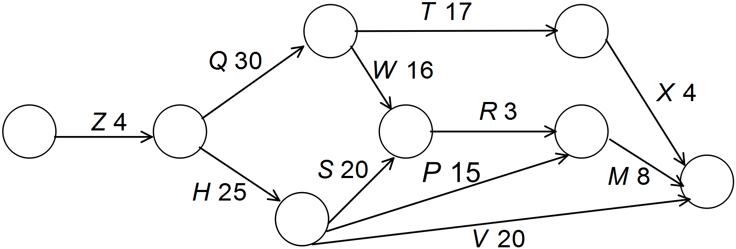

The following questions refer to the Richards’ project network for preparing for their picnic.

(a) For each task, determine the earliest start time (EST), the latest start time (LST) and record these on the network diagram. (3 marks)

(b) Identify the critical path. (1 mark)

(c) Determine the float time for task P. (2 marks)

(d) While preparing for a recent picnic, task P took an extra 8 minutes. How did this affect the minimum completion time for all of the tasks? Give a reason for your answer. (2 marks)

**End of Questions**

Additional working space

Question number: __________________

**Acknowledgements**

Data for the population of Perth suburbs was sourced from the Australian Bureau of Statistics.

© MAWA, 2016

This examination is Copyright but may be freely used within the school that purchases this licence.

* The items that are contained in this examination are to be used solely in the school for which they are purchased.
* They are not to be shared in any manner with a school which has not purchased their own licence.
* The items and the solutions/marking keys are to be kept confidentially and not copied or made available to anyone who is not a teacher at the school. Teachers may give feedback to students in the form of showing them how the work is marked but students are not to retain a copy of the paper or marking guide until the agreed release date stipulated in the purchasing agreement/licence.

*Published by The Mathematical Association of WA*

*12 Cobbler Place, MIRRABOOKA 6061*